Task on Terraform-01
1)Install Terraform on your PC
Install Terraform
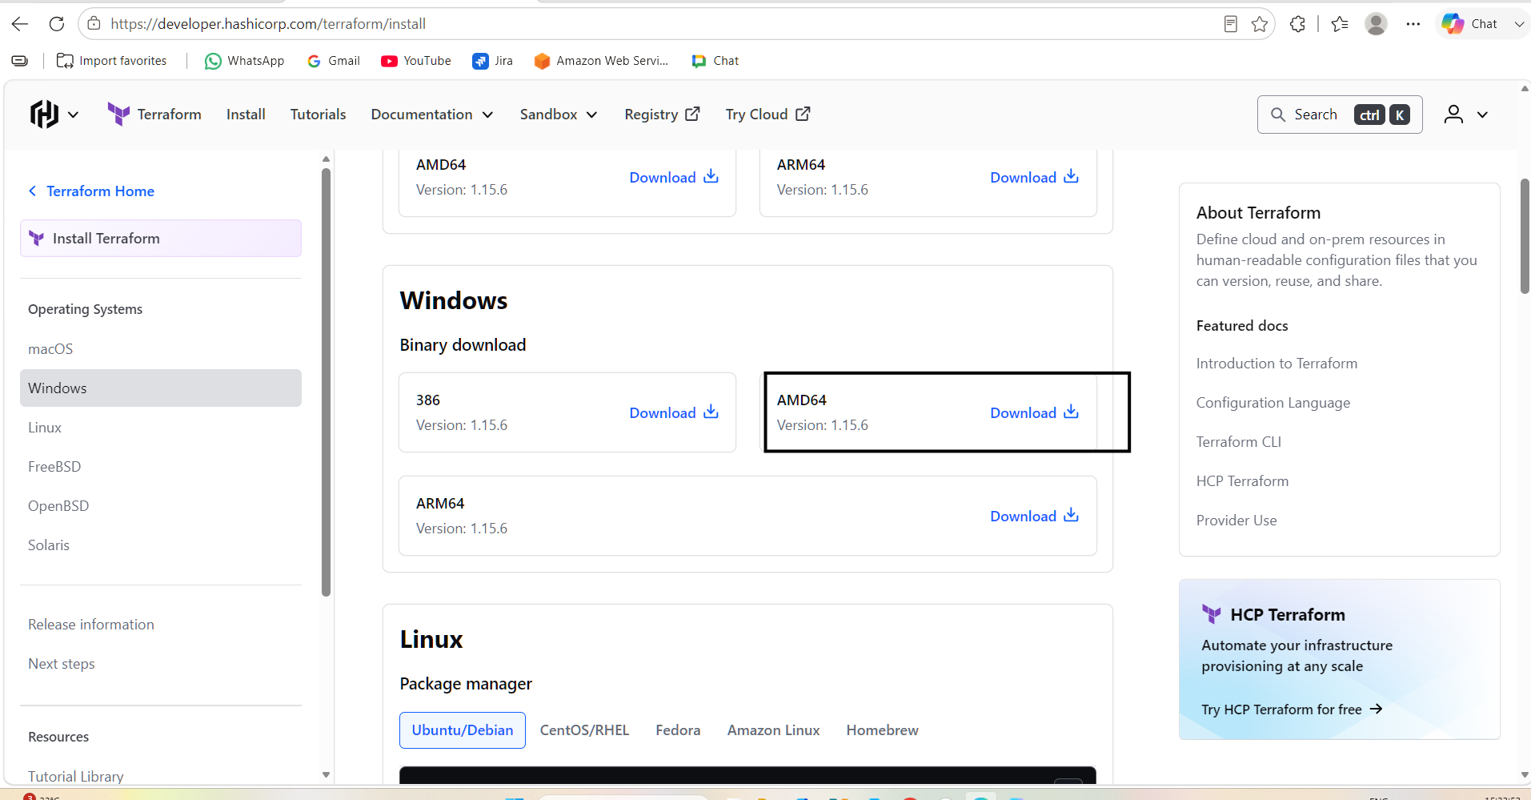
Extract the file in downloads
Then go to environment variables
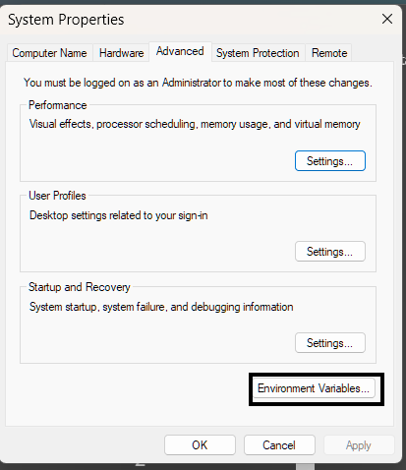
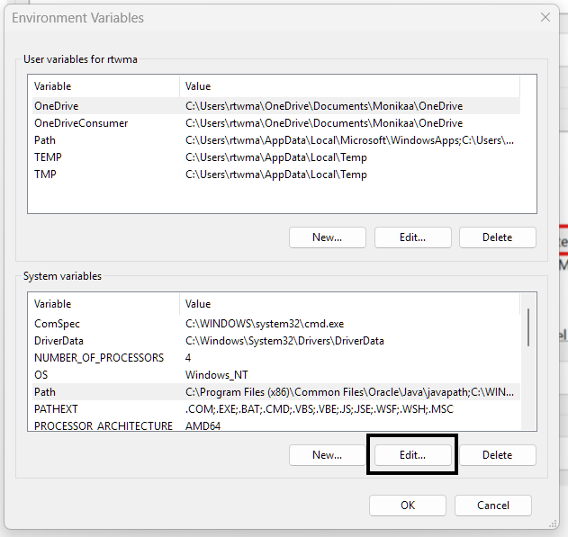
C:\Users\rtwma\Downloads\terraform_1.15.6_windows_amd64
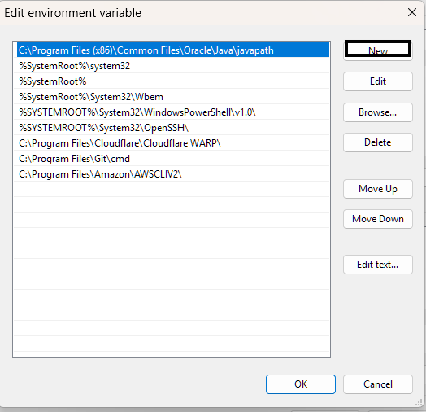
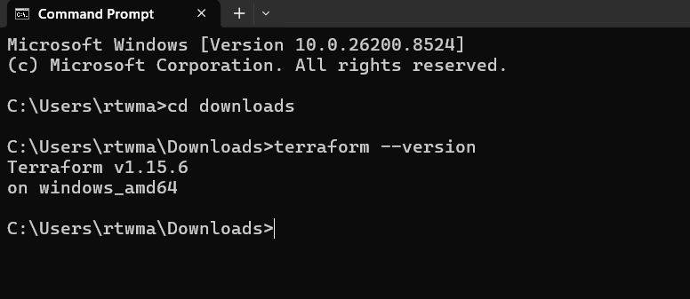
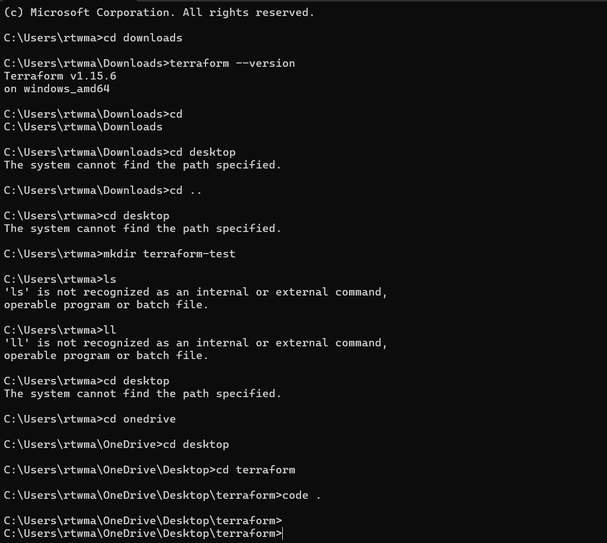
2). Execute all the templates shown in video.

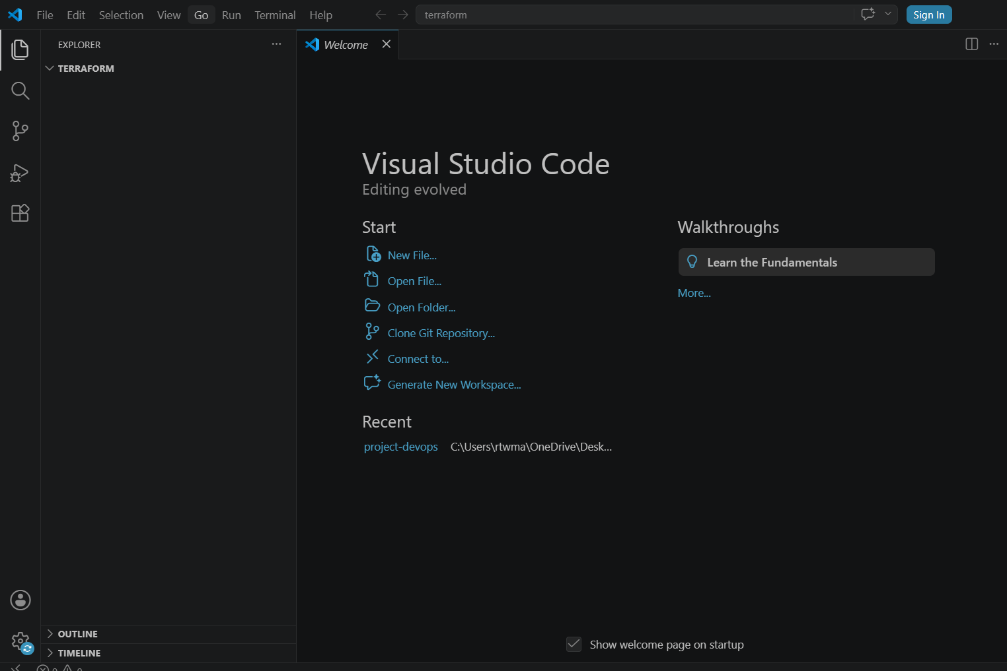
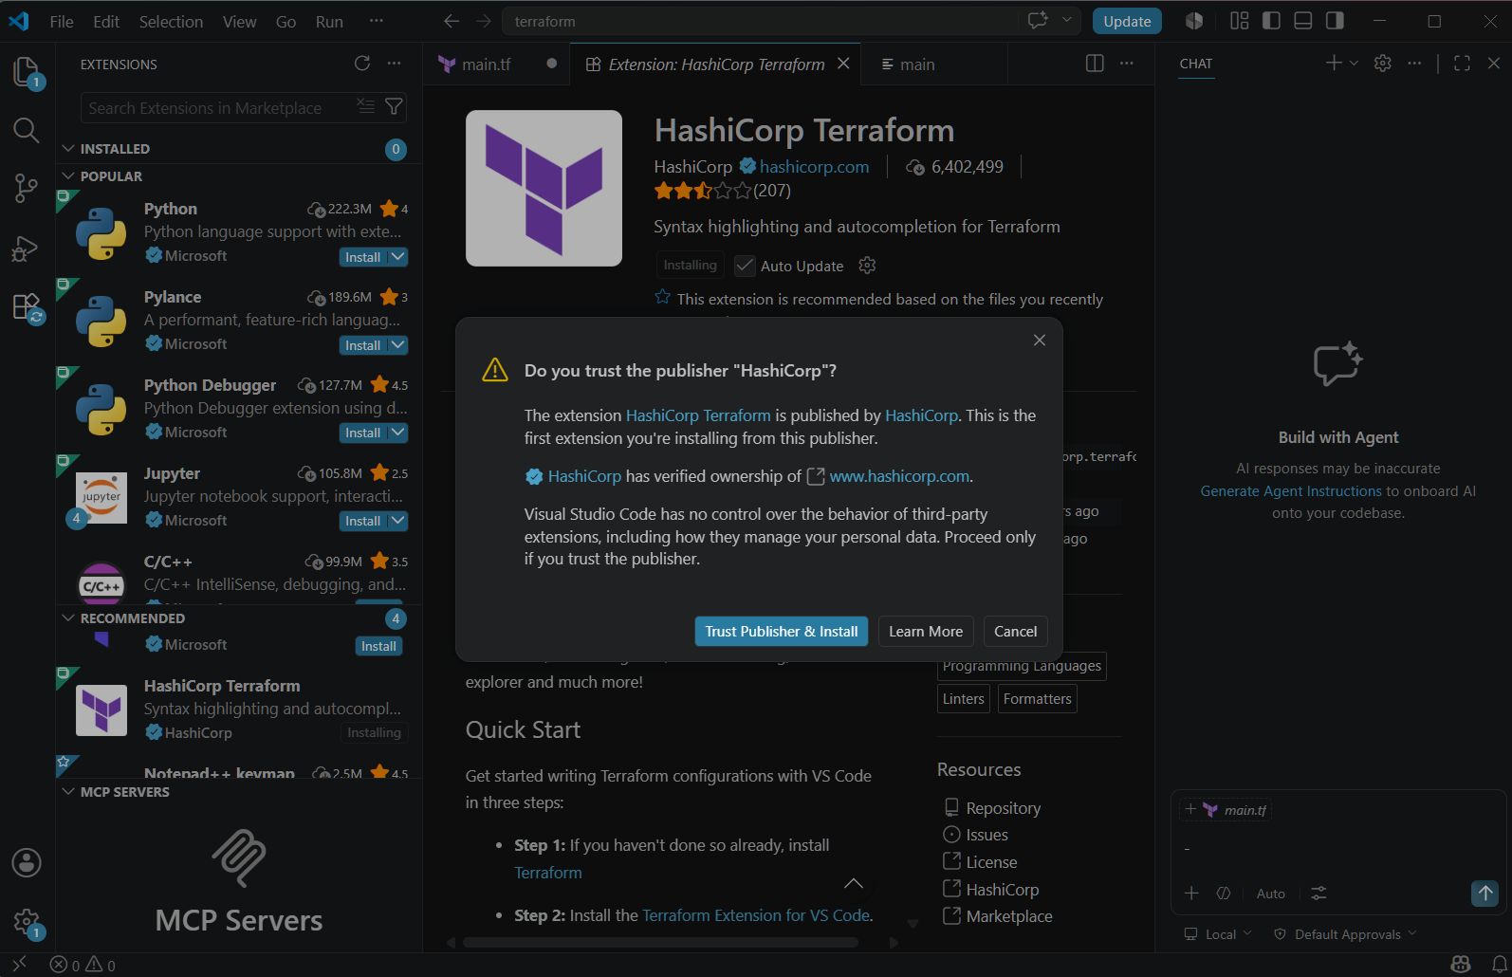
Terraform –version
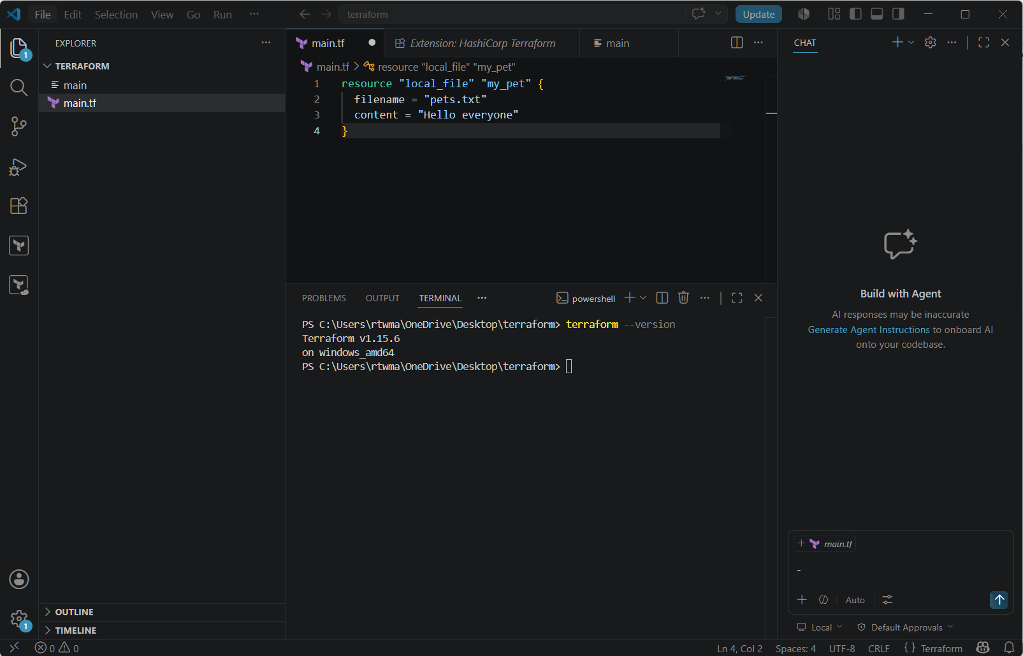
terraform init
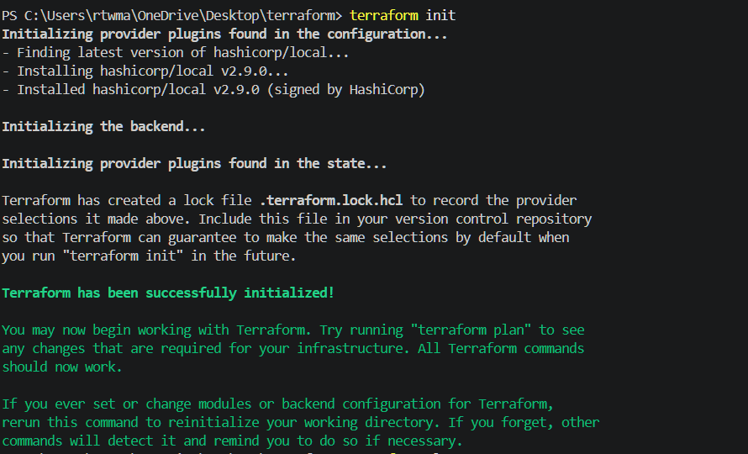
terraform plan
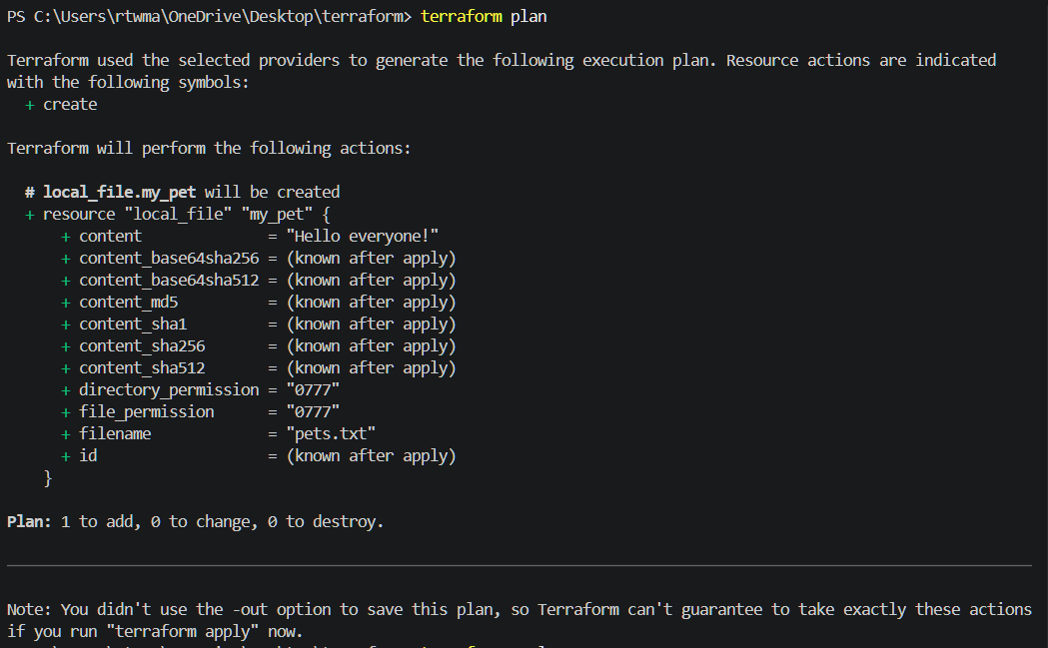
terraform apply
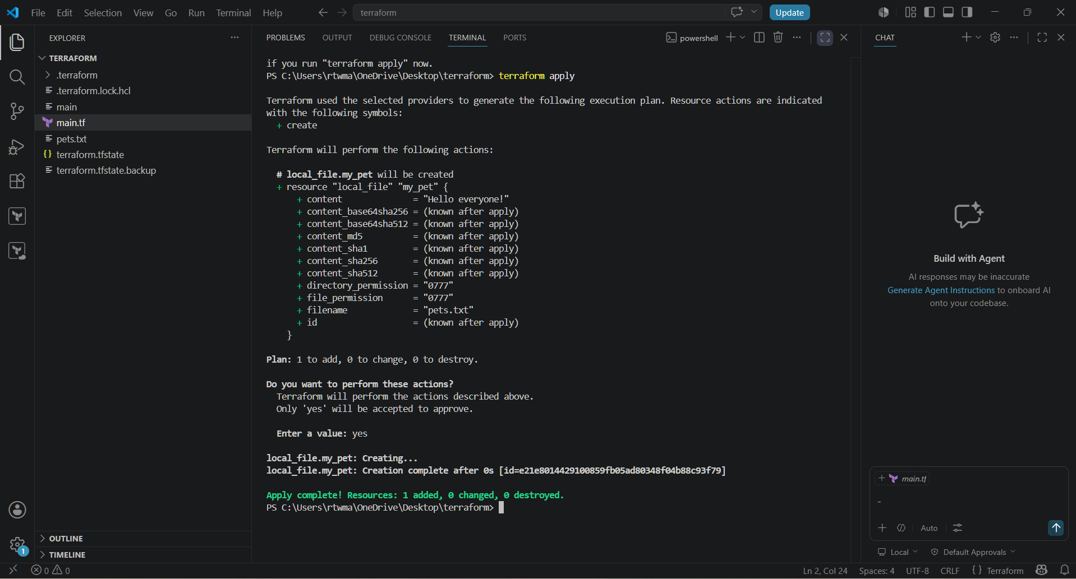
Terraform fmt
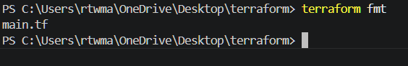
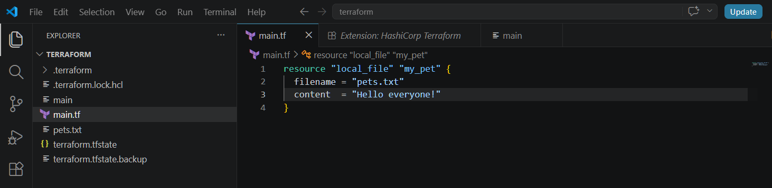
3) Note down below points, Terraform Init Terraform Plan Terraform Apply Terraform Provider.
Terraform Init
- First command in Terraform.
- Initializes the working directory.
- Downloads required providers and modules.
Terraform Plan
- Shows what changes Terraform will make.
- Compares current infrastructure with Terraform code.
- Does not make any changes.
Terraform Apply
- Creates, updates, or deletes infrastructure.
- Executes the changes shown in the plan.
- Updates the Terraform state file.
Terraform Provider
- Plugin that allows Terraform to interact with a cloud platform.
- Examples: AWS, Azure, GCP, Kubernetes.
- Downloaded during terraform init.

4)Integrate a sample Terraform template in Jenkins.
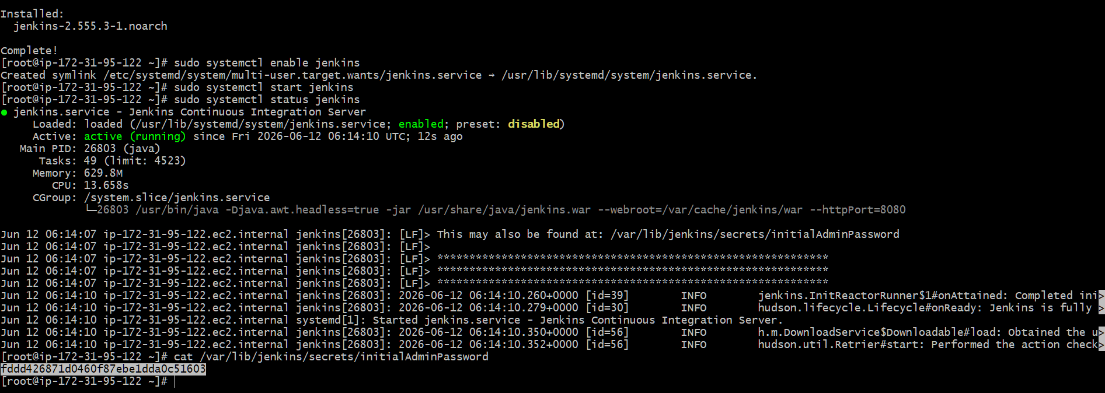
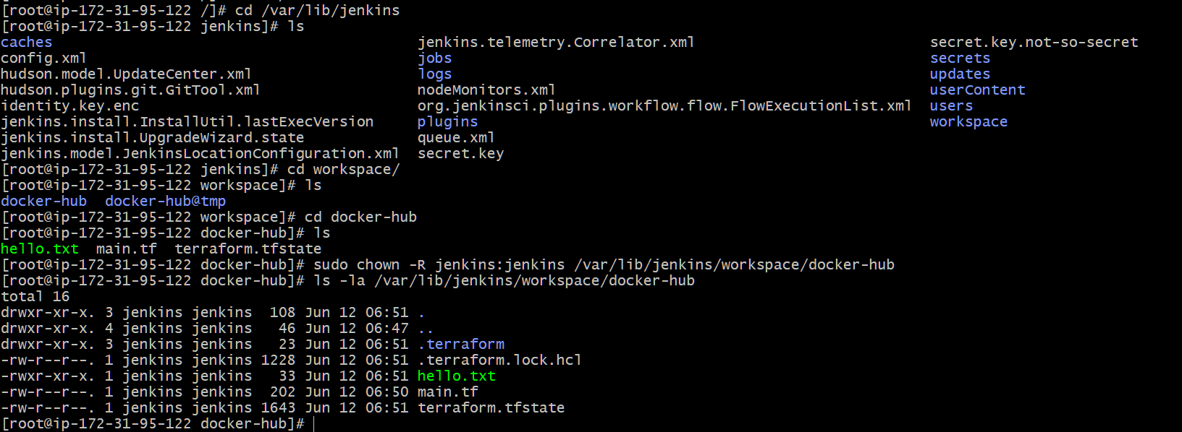

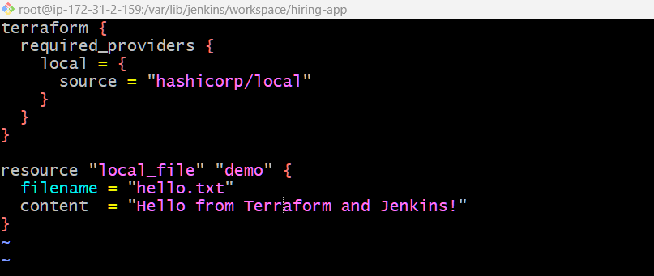
sudo yum install -y yum-utils
sudo yum-config-manager --add-repo
sudo yum-config-manager --add-repo https://rpm.releases.hashicorp.com/AmazonLinux/hashicorp.repo
sudo yum -y install terraform
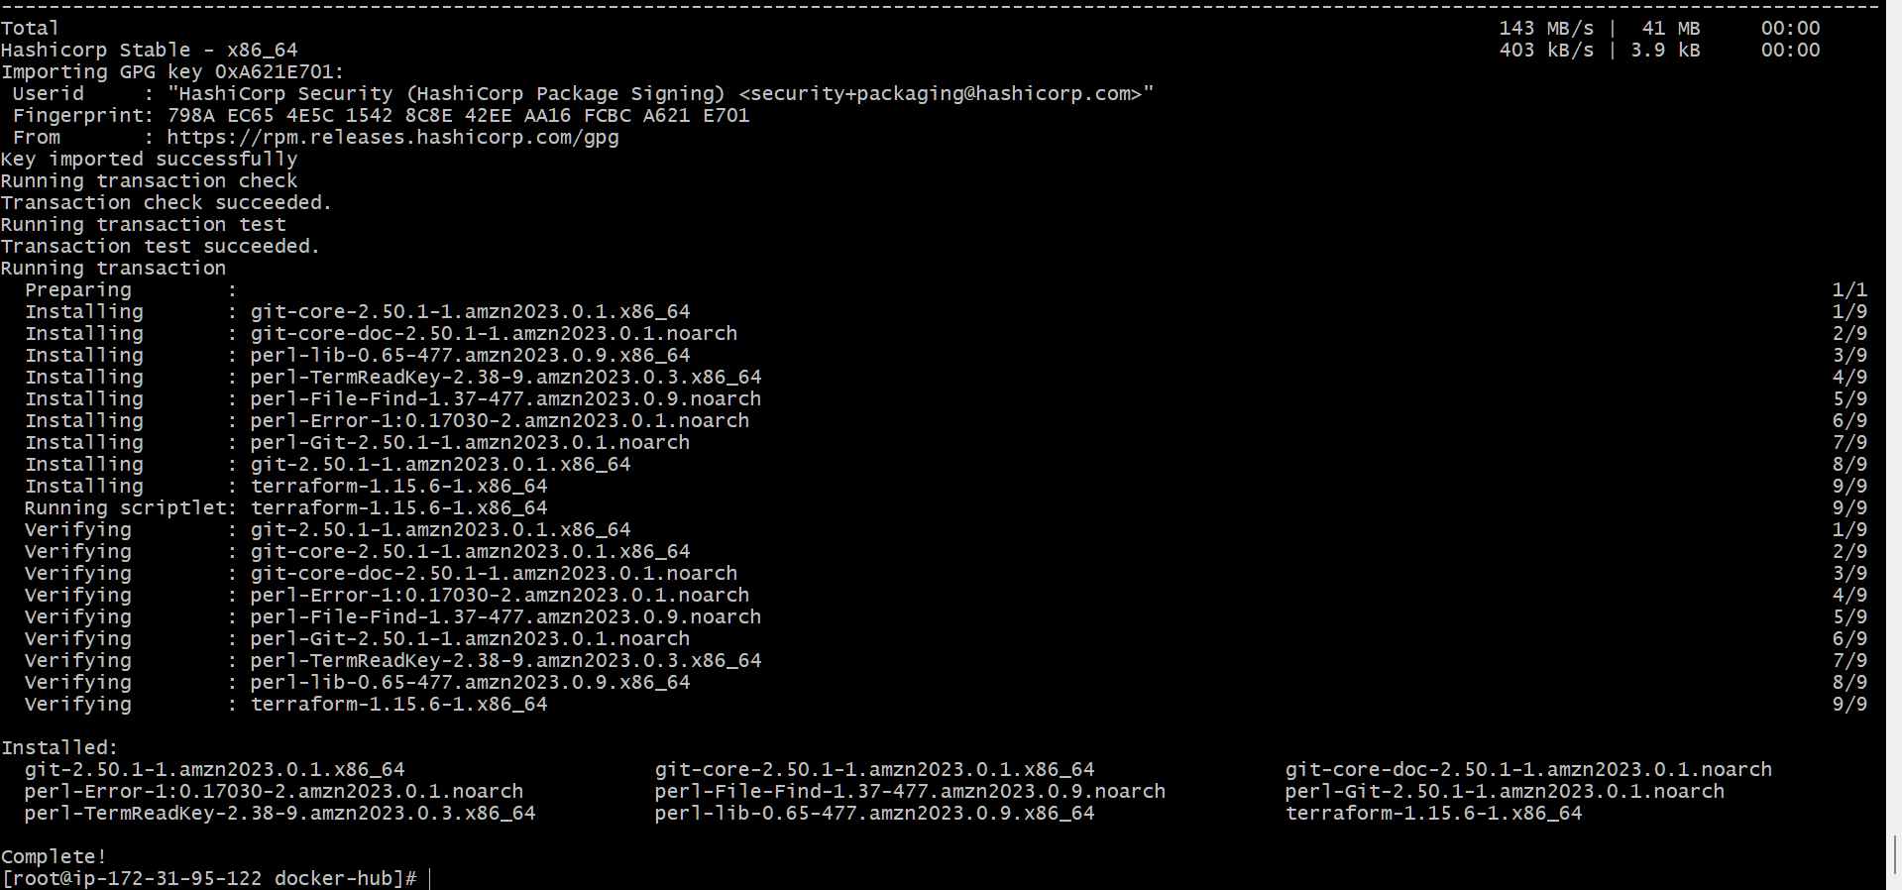
pipeline {
agent any

stages {

stage('Check Workspace') {
steps {
sh '''
echo "===== Jenkins Workspace ====="
pwd
echo ""

echo "===== Workspace Contents ====="
ls -la
'''
}
}

stage('Terraform Version') {
steps {
sh 'terraform --version'
}
}

stage('Terraform Init') {
steps {
sh 'terraform init'
}
}

stage('Terraform Plan') {
steps {
sh 'terraform plan'
}
}

stage('Terraform Apply') {
steps {
sh 'terraform apply -auto-approve'
}
}

stage('Verify Output') {
steps {
sh '''
echo "===== Files After Apply ====="
ls -la

echo ""
echo "===== hello.txt Content ====="
cat hello.txt
'''
}
}
}

post {
always {
echo 'Pipeline execution completed.'
}

success {
echo 'Terraform applied successfully.'
}

failure {
echo 'Pipeline failed.'
}
}
}
